**Sinister Transistor**

**User's Manual**

**The Mega Bytes**

Team Name: The Mega Bytes

Team Members:

* Mark Boutwell
* Greg Kelso
* Joel Gardyasz

Modification history:

|  |  |  |  |
| --- | --- | --- | --- |
| Version | Date | Who | Comment |
| V1.0 | 04/22/15 | Mark Boutwell | Initial Commit |
| ... |  |  |  |

**Contents of this Document**

System Description

System States

System Functions

Appendix – Acronyms and Abbreviations

**System Description**

Sinister Transistor is a top-down shoot ‘em up game set in the world of circuits. The player controls an evil transistor determined to destroy the CPU that has been controlling it. You will navigate through the treacherous circuit board filled with corrupt inductors, villainous capacitors and swarms of resistors that all wish to subdue you. Overcome the obstacles in your way to defeat the CPU kingpin and achieve circuit board domination. If you enjoy shoot ‘em up games or you just wish you could vent your frustration from years of electrical engineering classes, then you will enjoy this game.

**System States**

Using this System (On a Windows PC) – The game is running on a PC with a Windows 7/8/10 OS. The game is distributed as sinistertransister.exe and a data folder.

Using this System (On a Mac) – The game is running on a computer with Mac OS X 10.8+.

**System Functions**

Start a new game:

1. On a PC: double click “sinistertransistor.exe”

On a Mac: run sinistertransistor.app

1. Choose your graphics options and hit “Play!”

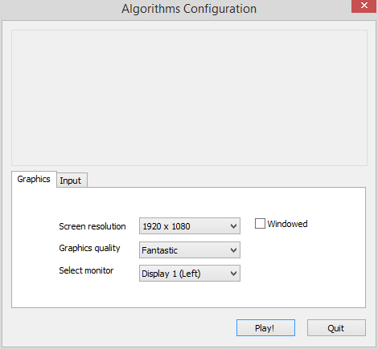

1. Click on “Play Game”. From this menu, you can also hit ”Quit” to close the game.

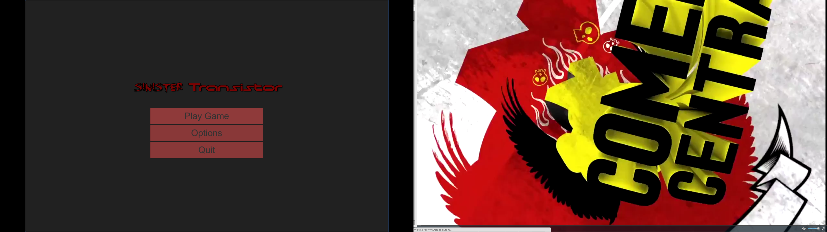

Controlling the character:

1. Once the game has started, use the arrow keys to move the character around the level.

Up/Down moves your character forwards or backwards

Left/Right rotates your character

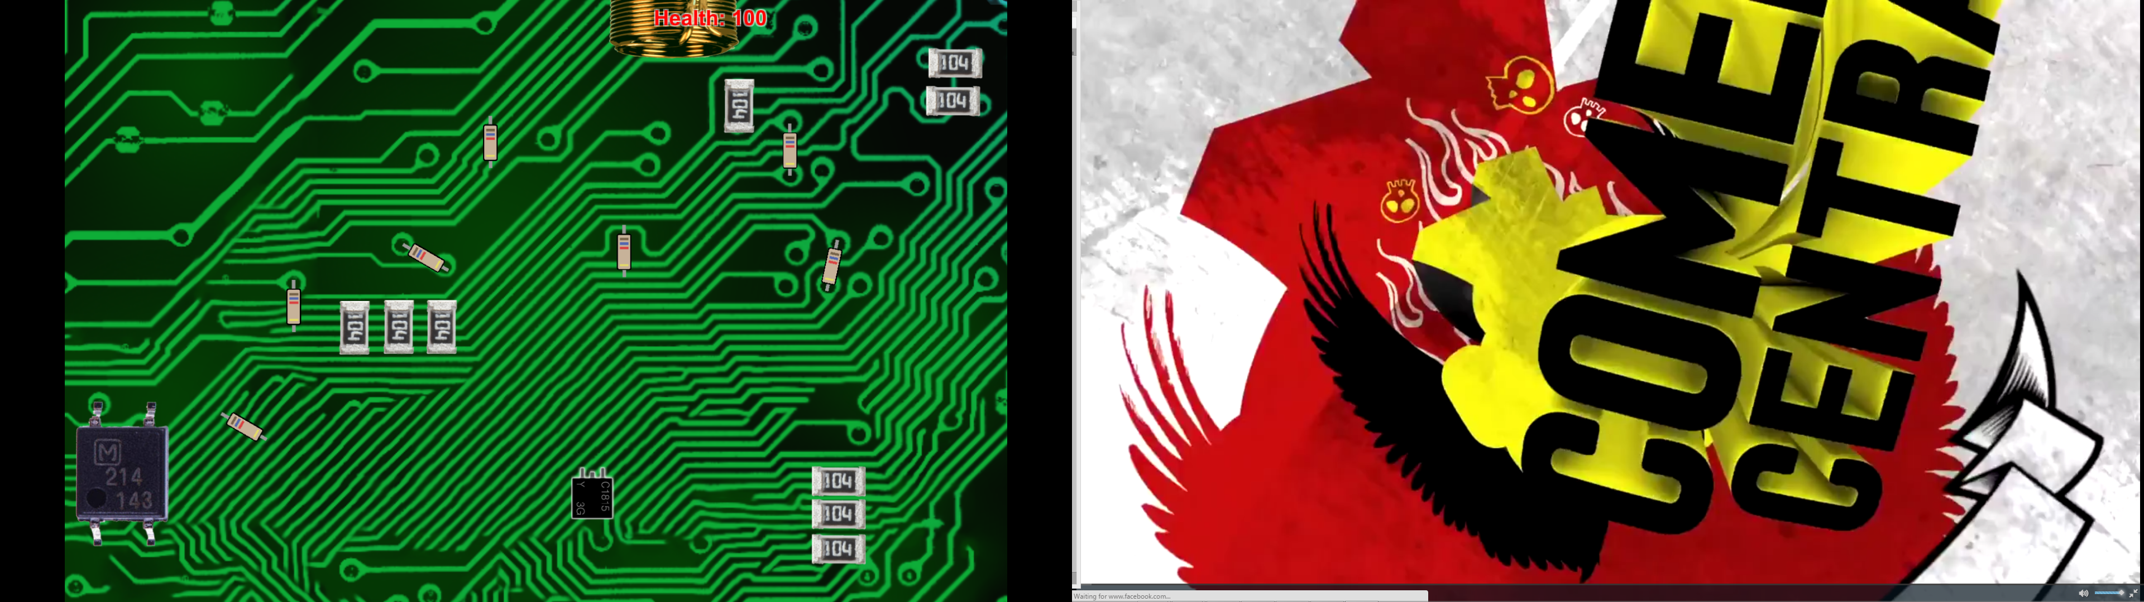

1. To attack, press the spacebar on your keyboard

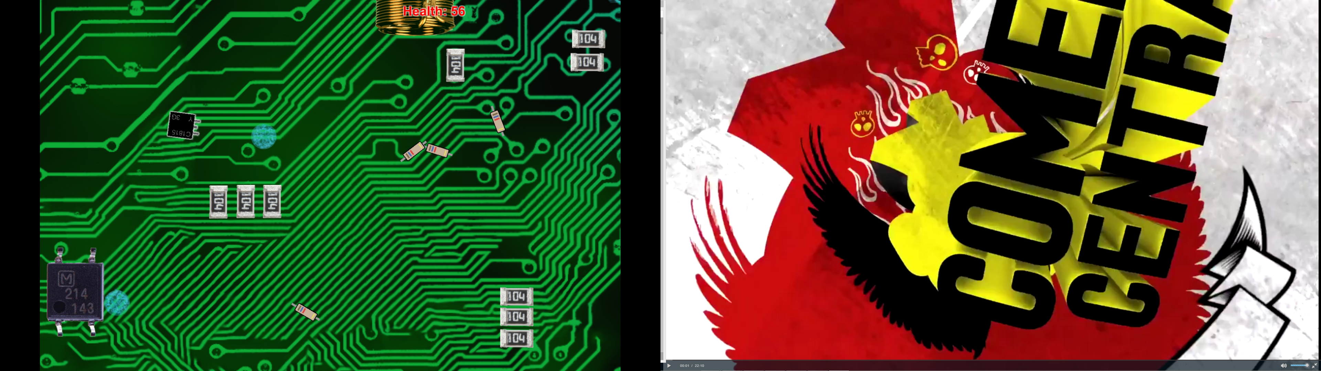

Navigating the levels:

1. Avoid obstacles like these:

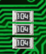

1. To go to the next stage, move through inductors/gates shown here:

 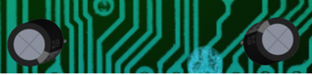

Defeating enemies:

1. Hit enemies with your attacks by pressing “space bar” until their health goes down to 0 and they disappear.
2. Resistors – these little guys will chase you around the map; blocking your path and zapping you if you touch them. Although they do not do much damage, they can surround you quickly so try to take them out one at a time.

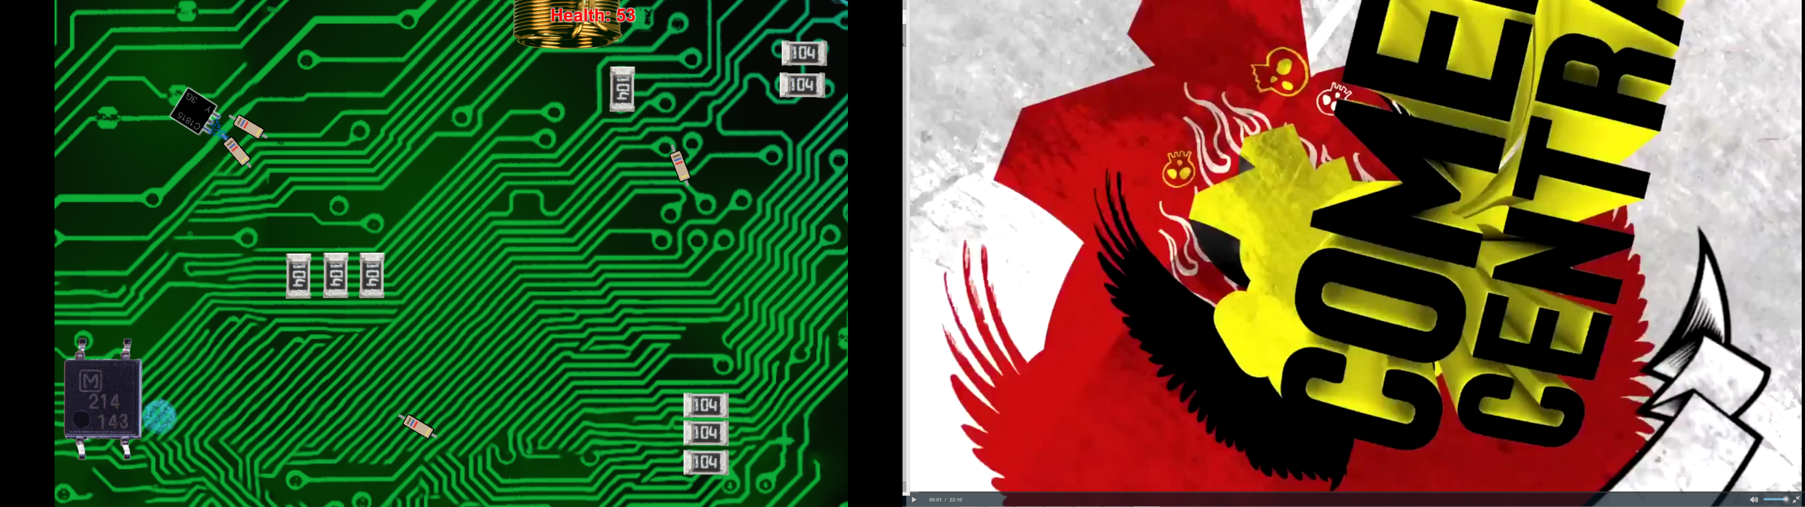

1. Inductors – This is the first boss you will encounter in the game. They do a lot of damage and large amount of health, but are slow. Keep your distance to avoid certain death.

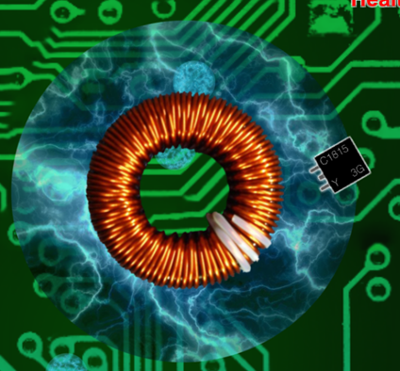

1. Capacitors – These towers have high health and damage, but are stationary. Their attacks will always follow the same paths. Learn their patterns and weave your character around the sparks.



Pausing the game:

1. To pause the game, press the “esc” button on your keyboard.

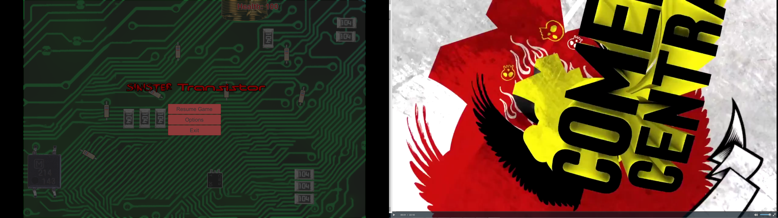

1. From this menu, you can hit “Resume Game” to continue playing or you can hit ”Exit” to return the main menu. If you hit “Exit”, your progress will not be saved.

Using the Power Up:

1. Keep an eye out for the Power Up. Moving your character over this item will increase your attack speed significantly. It will be very difficult to beat the game without it.

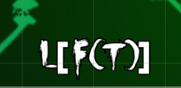

Winning the game:

1. To win, you must navigate through all 3 stages of the game and defeat the boss CPU called A99 located in the last stage of the game. It has extremely high amount of health and damage, so be careful and try to avoid his attacks.



1. Once you have defeated A99, a menu will appear signaling that you have won the game. From here you can click “Play Again” to go back to the main menu where you can start a new game or exit the game.

**Appendix – Acronyms and Abbreviations**

Boss – Enemy that is more difficult that other enemies

CPU – Central Processing Unit

Power Up – item that boosts your fighting efficiency

Shoot ‘em up – A video game genre in which the player dodge a large number of attacks and shoot down enemies